
Mobile number to be removed
Mail ID is : info@yugratho.com

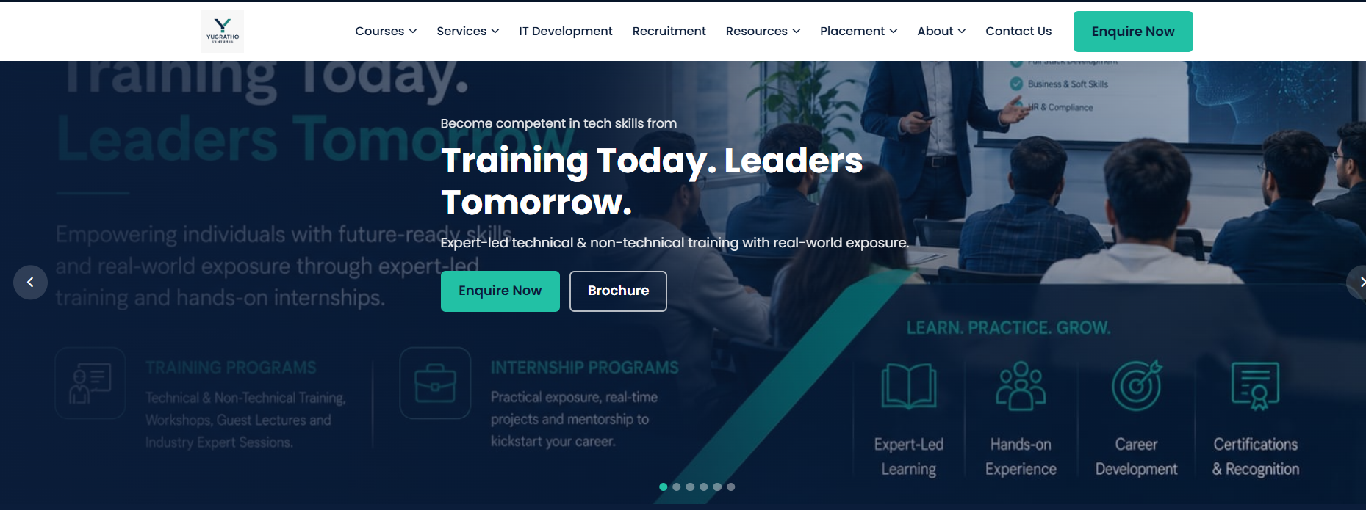
When opening the website, it should show our 3 Major Services – IT Services, Payroll & Compliance, HR Services, Training & Internship

In Corporate Training, page is showing of HR Conclave
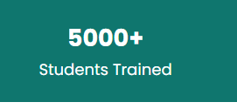
500000+ Candidates trained


Mention Most suitable for : B-Tech, M-Tech, MCA, BBA, MBA, Graduation, etc
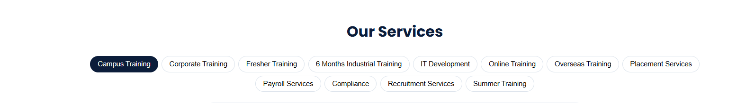
6 Months Industrial Training => 45 Days to 6 Months Industrial Training/Internship
Summer Training => Summer Training/Internship


Include B-Tech, M-Tech, MCA, BBA, MBA, Graduation, etc as well

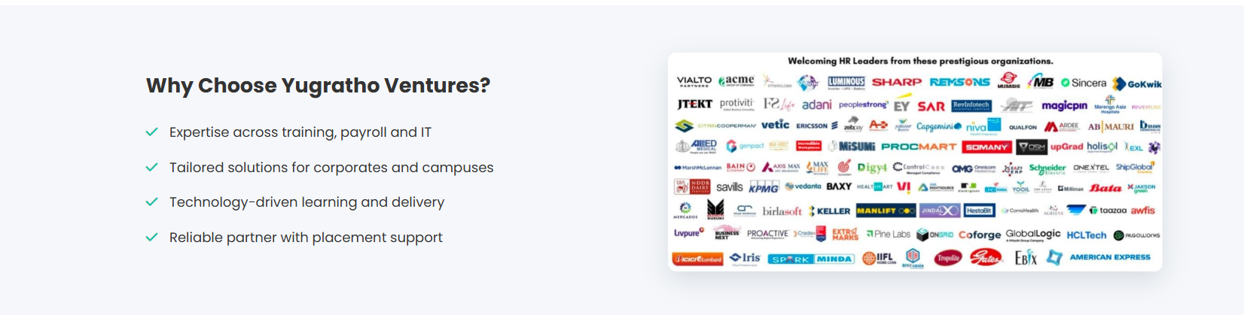
In the first Point add – Expertise across Training, Payroll & Compliance, IT & HR Services
Technology Driven to be mentioned as AI driven
Last point as 100% Placement record

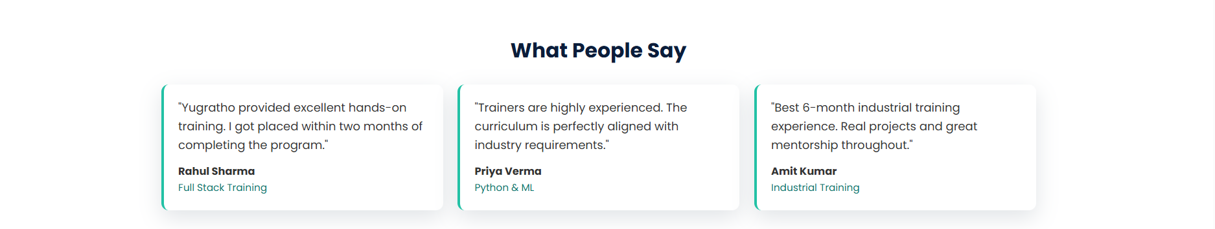
We can add 2-3 more Testimonial and keep it moving

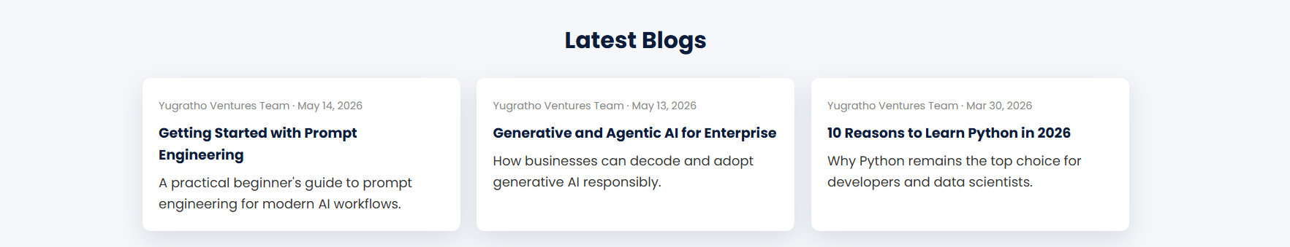Latest Blogs will have to be updated regularly. Else we can remove the date

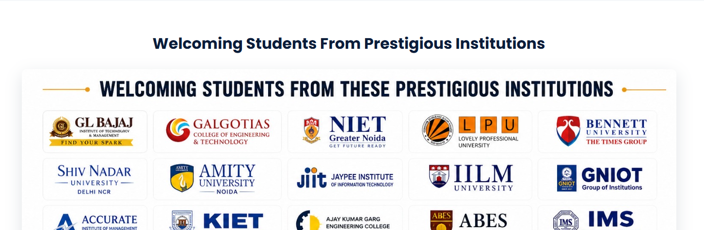
Academic partners


Need to be worked on

Link can redirect to message to 9955028663
Mention Mail ID : info@yugratho.com ; careers@yugratho.com
Linkedin ID : https://www.linkedin.com/company/107438295/admin/dashboard/
Instagram : https://www.instagram.com/yugrathoventures?utm_source=qr&igsh=MWlkNDNxZjZmcTBqbg==
LinkedIn QR Code :



Gemini watermark to be removed from all pages

This image to be used in home screen

Payroll and Compliance Services
View Courses to be removed
Use AI methodology and Technique word here as well

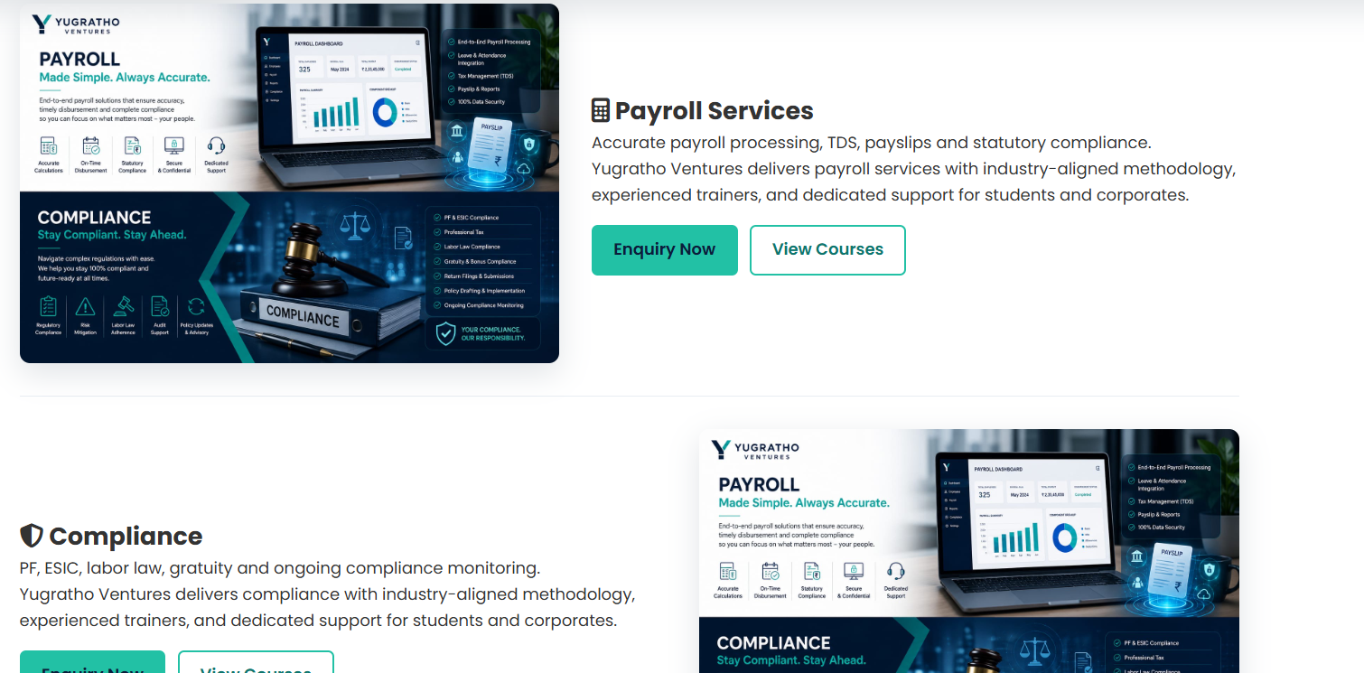
This can be clubbed together

This to be amended including 45 days to 6 months and include the same for all courses as per the details mentioned above

Vision to be changed as : The Bridge Between Potential and Professionalism
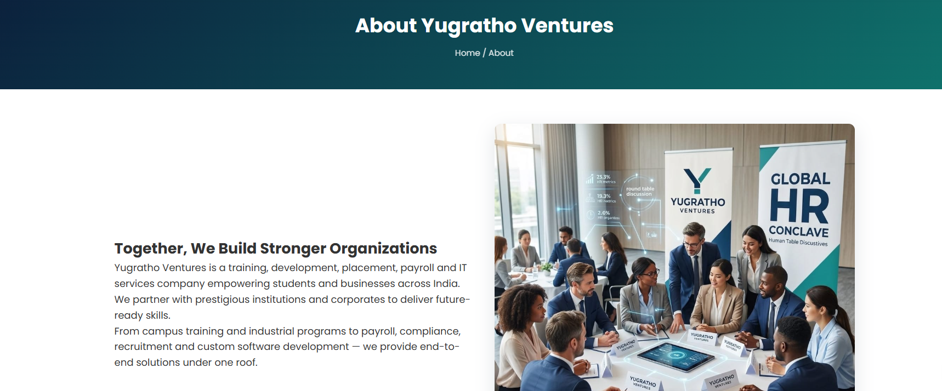
About Yugratho to be mentioned as :

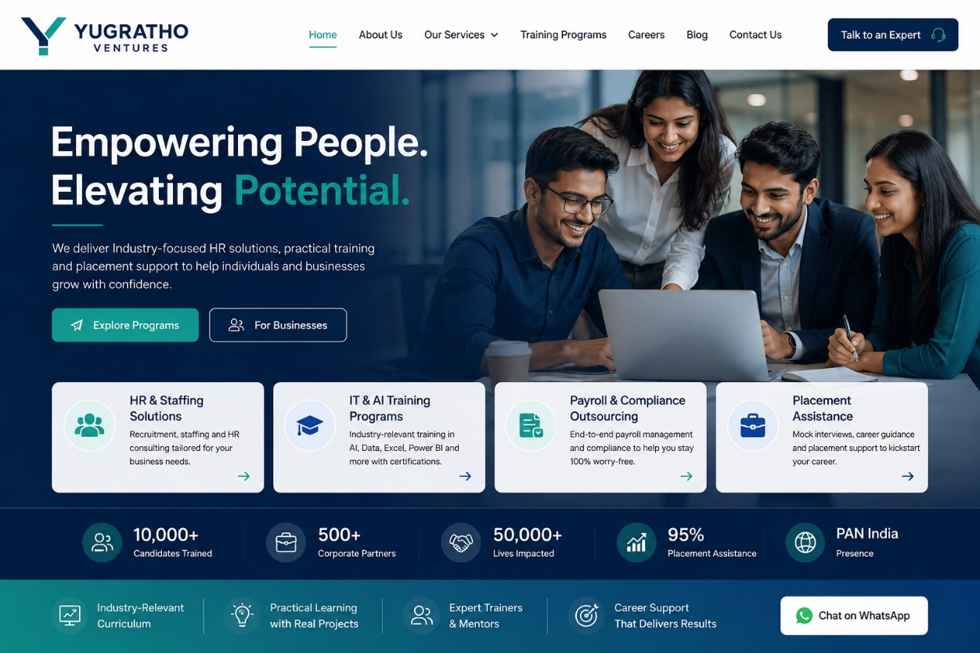
Home page should look like this. Instead of Placement Assistance, it should be AI Based IT Product and Services

Please create one Tab for Test to start and that can be used when we are going to a college for the Mock Interview and randomly no one can open that link. We are having one Google Form made for the same.

Few images of HR events to be included. Please don’t upload any image containing my face.

